**Michael Le (21689299) Assessment 2 PART II REPORT**

**Name of the distribution:**

Beta Distribution

**Parameters:**

Where are shape parameters.

**Notation used for the distribution:**

**X**

**Density function:**

**Where is the Beta function are in terms of the gamma function.**

**NOTE:** In the textbook it uses p and q, (where p = and q = )

**Calculations:**

**By using R to calculate with X , the following results are obtained:**

**N = 1000,**

= 0.9999339

0.5

**N = 1000,**

= 0.9999339

0.25

**Plots of the pdf and cdf distributions**

Plotting the beta density distribution in R using alpha 1 and beta 3.

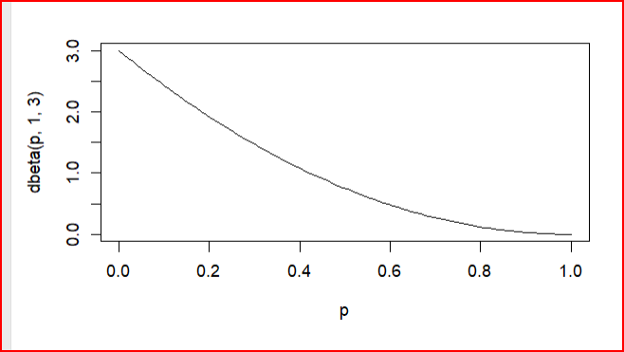

Creating the beta distribution density in R with parameters alpha=2 and beta = 2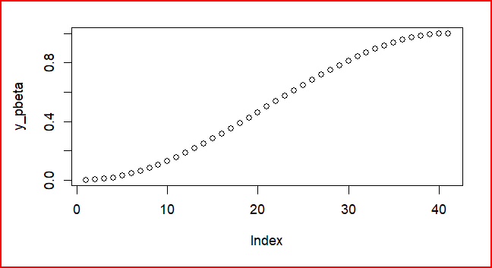

Plotting the pdf of the Beta Distribution in R using alpha 2 and beta 2 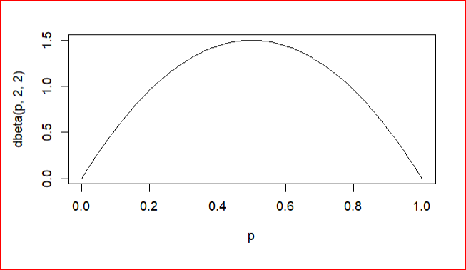

Creating the beta distribution density in R with parameters alpha=1 and beta = 3

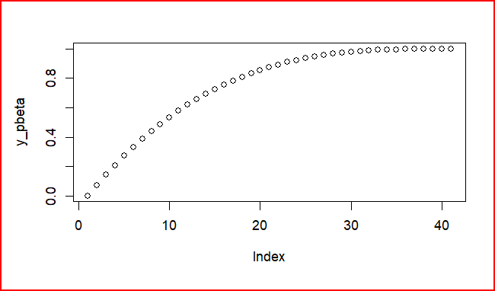

For each scenarios following above, every time we increase n (the number of samples) as it gets larger from this distribution which calculates an average for every sample that is drawn, the sample average must follow closer to a standard normal distribution.

Christian, W. (2007). *Hand-book on STATISTICAL DISTRIBUTIONS for experimentalists*. Particle Physics Group Fysikum University of Stockholm